**Background**

The command line is a text interface for your computer. It’s a program that takes in commands, which it passes on to the computer’s operating system to run.

From the command line, you can navigate through files and folders on your computer, just as you would with Windows Explorer on Windows or Finder on Mac OS. The difference is that the command line is fully text-based.

Here’s an appendix of commonly used commands.

**Commands**

**>**

$ cat oceans.txt > continents.txt

> takes the standard output of the command on the left and redirects it to the file on the right.

**>>**

$ cat glaciers.txt >> rivers.txt

>> takes the standard output of the command on the left and *appends* (adds) it to the file on the right.

**<**

$ cat < lakes.txt

< takes the standard input from the file on the right and inputs it into the program on the left.

**|**

$ cat volcanoes.txt | wc

| is a “pipe”. The | takes the standard output of the command on the left, and *pipes* it as standard input to the command on the right. You can think of this as “command to command” redirection.

**~/.bash_profile**

$ nano ~/.bash_profile

**~/.bash_profile** is the name of file used to store environment settings. It is commonly called the “bash profile”. When a session starts, it will load the contents of the bash profile before executing commands.

**alias**

alias pd="pwd"

The alias command allows you to create keyboard shortcuts, or aliases, for commonly used commands.

**cd**

$ cd Desktop/

cd takes a directory name as an argument, and switches into that directory.

$ cd jan/memory

To navigate directly to a directory, use cd with the directory’s path as an argument. Here, cd jan/memory/ command navigates directly to the **jan/memory** directory.

**cd ..**

$ cd ..

To move up one directory, use cd ... Here, cd .. navigates up from **jan/memory/** to **jan/**.

**cp**

$ cp ada_lovelace.txt historical/

cp copies files or directories. Here, we copy the file **ada_lovelace.txt** and place it in the **historical/** directory

**Wildcards (*)**

$ cp * satire/

The wildcard * selects all of the files in the current directory. The above example will copy all of the files in the current directory to the directory called **satire**. There are other types of wildcards, too, which are beyond the scope of this glossary.

$ cp m*.txt scifi/

Here, m*.txt selects all files in the working directory starting with “m” and ending with “.txt”, and copies them to scifi/.

**env**

$ env

The env command stands for “environment”, and returns a list of the environment variables for the current user.

**env | grep VARIABLE**

$ env | grep PATH

env | grep PATH is a command that displays the value of a single environment variable.

**export**

export USER="Jane Doe"

export makes the variable to be available to all child sessions initiated from the session you are in. This is a way to make the variable persist across programs.

**grep**

$ grep "Mount" mountains.txt

grep stands for “global regular expression print”. It searches files for lines that match a pattern and returns the results. It is case sensitive.

**grep -i**

$ grep -i "Mount" mountains.txt

grep -i enables the command to be case insensitive.

**grep -R**

$ grep -R Arctic /home/ccuser/workspace/geography

grep -R searches all files in a directory and outputs filenames and lines containing matched results. -R stands for “recursive”.

**grep -Rl**

$ grep -Rl Arctic /home/ccuser/workspace/geography

grep -Rl searches all files in a directory and outputs only filenames with matched results. -R stands for “recursive” and l stands for “files with matches”.

**HOME**

$ echo $HOME

The HOME variable is an environment variable that displays the path of the home directory.

**ls**

$ ls  
2014  2015  hardware.txt

ls lists all files and directories in the working directory

**ls -a**

$ ls -a  
.  ..  .preferences  action  drama comedy  genres.xt

ls -a lists all contents in the working directory, including hidden files and directories

**ls -l**

$ ls -l  
drwxr-xr-x 5  cc  eng  4096 Jun 24 16:51  action  
drwxr-xr-x 4  cc  eng  4096 Jun 24 16:51  comedy  
drwxr-xr-x 6  cc  eng  4096 Jun 24 16:51  drama  
-rw-r--r-- 1  cc  eng     0 Jun 24 16:51  genres.txt

ls -l lists all contents of a directory in long format. [Here’s what each column means](https://www.codecademy.com/courses/learn-the-command-line/lessons/command-line-manipulation/exercises/ls-l).

**ls -t**

ls -t orders files and directories by the time they were last modified.

**mkdir**

$ mkdir media

mkdir takes in a directory name as an argument, and then creates a new directory in the current working directory. Here we used mkdir to create a new directory named **media/**.

**mv**

$ mv superman.txt superhero/

To move a file into a directory, use mv with the source file as the first argument and the destination directory as the second argument. Here we move superman.txt into superhero/.

**nano**

$ nano hello.txt

*nano* is a command line text editor. It works just like a desktop text editor like TextEdit or Notepad, except that it is accessible from the command line and only accepts keyboard input.

**PATH**

$ echo $PATH  
   
/home/ccuser/.gem/ruby/2.0.0/bin:/usr/local/sbin:/usr/local/bin:/usr/bin:/usr/sbin:/sbin:/bin

PATH is an environment variable that stores a list of directories separated by a colon. Each directory contains scripts for the command line to execute. PATH lists which directories contain scripts.

**pwd**

$ pwd  
/home/ccuser/workspace/blog

pwd prints the name of the working directory

**rm**

$ rm waterboy.txt

rm deletes files. Here we remove the file waterboy.txt from the file system.

**rm -r**

$ rm -r comedy

rm -r deletes a directory and all of its child directories.

**sed**

$ sed 's/snow/rain/' forests.txt

sed stands for “stream editor”. It accepts standard input and modifies it based on an *expression*, before displaying it as output data.

In the expression 's/snow/rain/':

* s: stands for “substitution”.
* snow: the search string, the text to find.
* rain: the replacement string, the text to add in place.

**sort**

$ sort lakes.txt

sort takes a filename or standard input and orders each line alphabetically, printing it to standard output.

**standard error**

*standard error*, abbreviated as stderr, is an error message outputted by a failed process.

**source**

source ~/.bash_profile

source activates the changes in **~/.bash_profile** for the current session. Instead of closing the terminal and needing to start a new session, source makes the changes available right away in the session we are in.

**standard input**

*standard input*, abbreviated as stdin, is information inputted into the terminal through the keyboard or input device.

**standard output**

*standard output*, abbreviated as stdout, is the information outputted after a process is run.

**touch**

$ touch data.txt

touch creates a new file inside the working directory. It takes in a file name as an argument, and then creates a new empty file in the current working directory. Here we used touch to create a new file named keyboard.txt inside the 2014/dec/ directory.

If the file exists, touch is used to update the modification time of the file

**uniq**

$ uniq lakes.txt

uniq, short for “unique”, takes a filename or standard input and prints out every line, removing any exact duplicates.

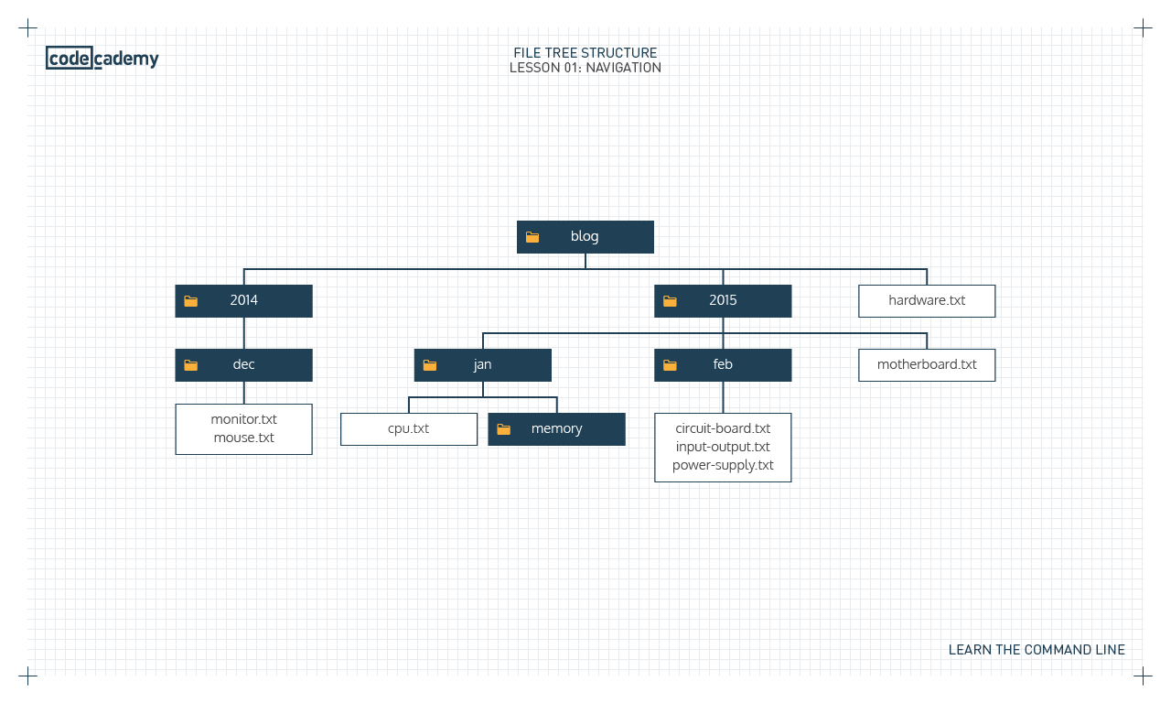

**NAVIGATION**

Review

Congratulations! You’ve learned five commands commonly used to navigate the filesystem from the command line. What can we generalize so far?

* The *command line* is a text interface for the computer’s operating system. To access the command line, we use the terminal.
* A *filesystem* organizes a computer’s files and directories into a tree structure. It starts with the *root directory*. Each parent directory can contain more child directories and files.
* From the command line, you can navigate through files and folders on your computer:
  + pwd outputs the name of the current working directory.
  + ls lists all files and directories in the working directory.
  + cd switches you into the directory you specify.
  + mkdir creates a new directory in the working directory.
  + touch creates a new file inside the working directory.
* You can use helper commands to make navigation easier:
  + clear clears the terminal
  + tab autocompletes the name of a file or directory
  + ↑ and ↓ allow you to cycle through previous commands

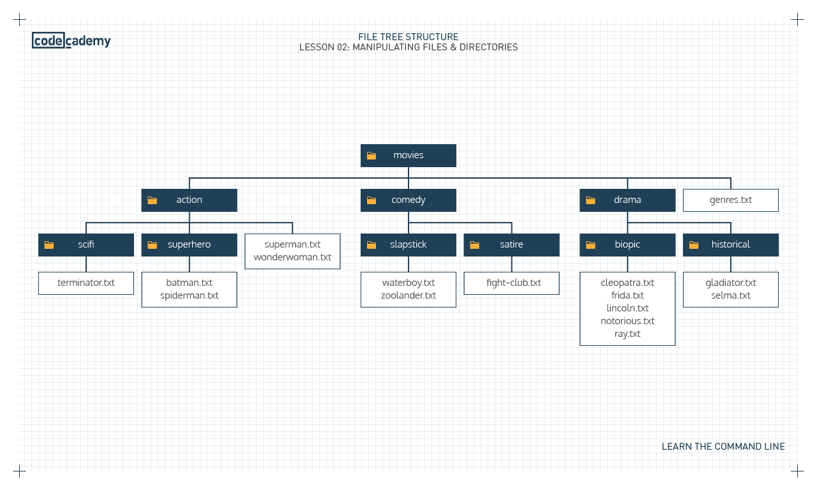

**MANIPULATION**

Review

Congratulations! You learned how to use the command line to view and manipulate the filesystem. What can we generalize so far?

* Options modify the behavior of commands:
  + ls -a lists all contents of a directory, including hidden files and directories
  + ls -l lists all contents in long format
  + ls -t orders files and directories by the time they were last modified
  + Multiple options can be used together, like ls -alt
* From the command line, you can also copy, move, and remove files and directories:
  + cp copies files
  + mv moves and renames files
  + rm removes files
  + rm -r removes directories
* Wildcards are useful for selecting groups of files and directories

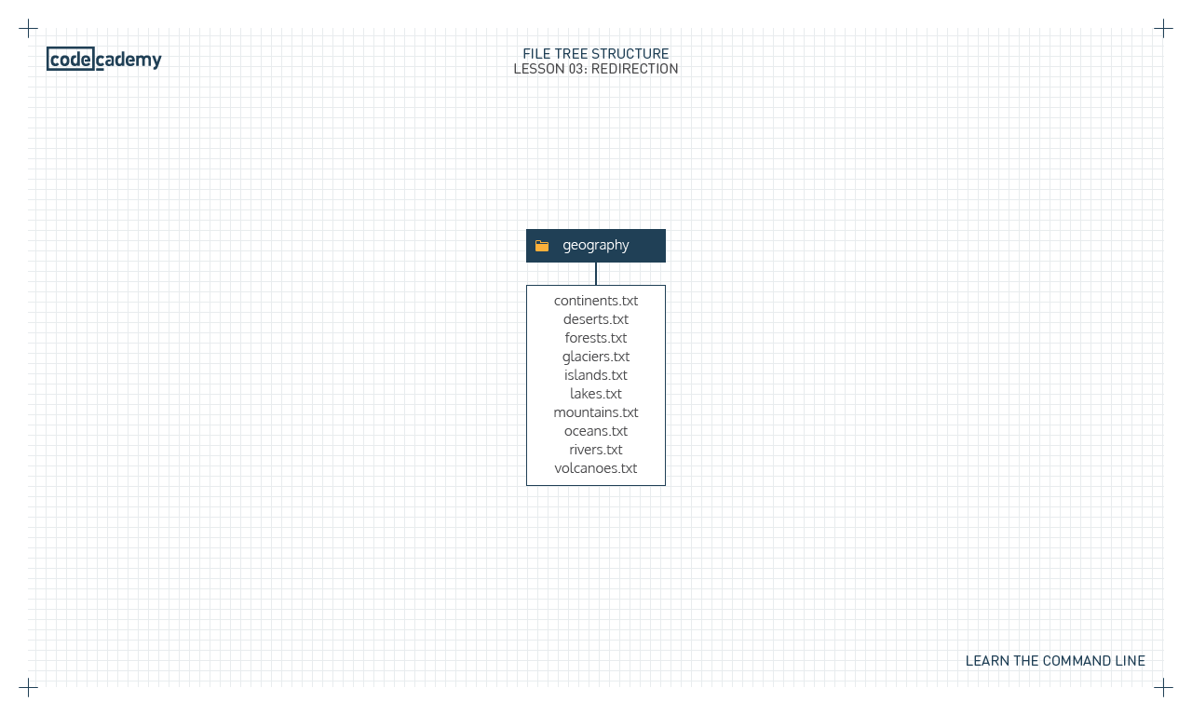

**REDIRECTION**

Review

Congratulations! You learned how to use the command line to redirect standard input and standard output. What can we generalize so far?

* *Redirection* reroutes standard input, standard output, and standard error.
* The common redirection commands are:
  + > redirects standard output of a command to a file, overwriting previous content.
  + >> redirects standard output of a command to a file, appending new content to old content.
  + < redirects standard input to a command.
  + | redirects standard output of a command to another command.
* A number of other commands are powerful when combined with redirection commands:
  + sort: sorts lines of text alphabetically.
  + uniq: filters duplicate, adjacent lines of text.
  + grep: searches for a text pattern and outputs it.
  + sed : searches for a text pattern, modifies it, and outputs it.